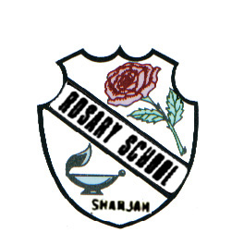
UNITED ARAB EMIRATES
ROSARY SCHOOL / HALWAN
Licensed from the Ministry of Education
Under No. ( 50 )

دولة الامارات العربية المتحدة
مدرسة الوردية الخاصة / حلوان
المرخصة من وزارة التربية والتعليم
تحت رقم ( 50 )

Our Vision: Innovative education for a knowledge, pioneering, and global society.
Department of English 2018-2019
Unit-5 (Worksheet-1)
Name ……………………………………… Grade:1 Sec:……...... Date:…/…/….
Q1 Recognize the describing words (adjectives) from the following vocabulary.
looking fish bright came bossy spotty swimming funny along swish boastful brown were shy

Q2 Use the following high frequency words to complete the sentences.
and was said the were

- So _____ big bad fish leaves me alone.
- I am bright ______ funny.
- Two funny fish _______ swimming in the sea.
- The big fish _______ bad and scary.
- One funny fish _____, “Look at me.”
Q3. Identify and number the events in correct order.
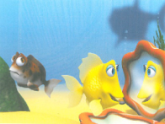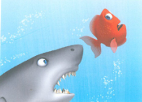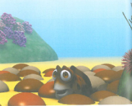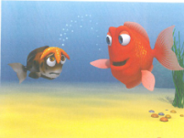
_______ _______ _______ _______
Q4. Read Student’s Book Pages 42-44 and answer the following questions?
a. What is the title of the story?
______________________________________________________
b. Prove which fish was clever?
______________________________________________________
c. How many fish were eaten by the big fish?
___________________________________
d. Categorize the suitable adjectives to describe each fish.
funny bright boastful spotty clever shy bossy

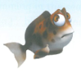________________
________________
________________
________________
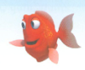________________
________________
________________
________________

e. Who said these words?
No one ever looks at me. (____________________)
I am as bright as the sun. (____________________)

Q5. State the color words for the following.
- The zebra is __________ and ___________.
- The leaves are ___________
- The sky is ________
- The strawberry is _______
- The chocolate is___________

Q6. Read and color.
- This is Tom.
- His hair is black and shirt is blue.
- He is wearing brown trousers and white shoes.
- His skateboard is yellow and green.

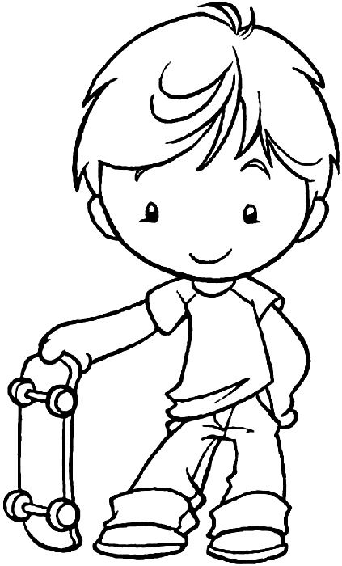

Q7. Match the ‘_ight’ words for the following pictures.
fright night light flight right

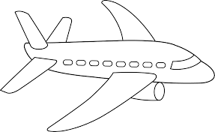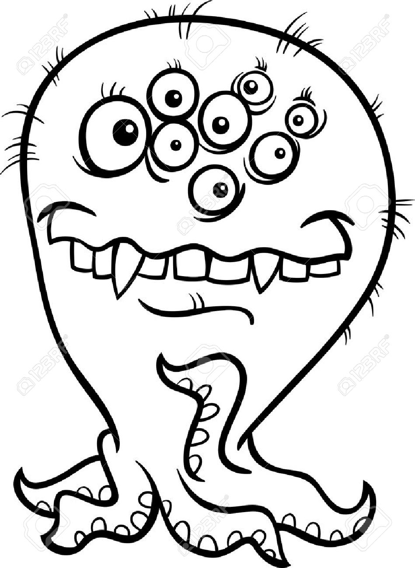
___________ ___________ _________ ____________ __________

Q 8. Construct words by adding vowels.
- l___mp 6. r__st
- bo__k 7. dr___m
- h__de 8. f_nny
- __ight 9. br__ght
- mo_n 10. sa__d

Q9. Connect the alphabet letters to make the picture.

