UNITED ARAB EMIRATES
دولة الامارات العربية المتحدة
مدرسة الوردية الخاصة / حلوان
المرخصة من وزارة التربية والتعليم
تحت رقم ( 50 )

ROSARY SCHOOL / HALWAN
Licensed from the Ministry of Education
Under No. ( 50 )
Our Vision: Innovative education for a knowledge, pioneering, and global society.
DEPARTMENT OF ENGLISH 2018-2019
Worksheet –Unit-5 Funny Fish

Name:______________________________ Grade:1 Sec:______ Date:____/1/2019

Q.1. Identify the characters that said the following and write.
- ‘I’m the best fish here.’ __________________
- ‘No one ever looks at me’. _________________
- ‘Look at ME! I am as bright as the Sun!’ _______________
- ‘He can’t see me!’

Q.2. Put a tick () for the true statement.
1. The funny fish were swimming in the lake.
The funny fish were swimming in the sea.
2. The brown fish hid under a stone.
The brown fish hid under a plant.
3. The red fish was boastful.
The red fish was shy.
4. One fish was orange like the carrot.
One fish was yellow like the sun.
5. The yellow fish was clever.
The brown fish was clever.

Q.3 Select the best answer.
a. The red fish was_______________. (bossy, clever, shy)
b. The yellow fish compared itself with the _________. (sun, moon, stars)
c. The brown fish looked like a ________. (flower, stone, sun)

Q4. Use the words to describe the object, animal, fruit, vegetable or flower in each sentence.
red - green – purple – yellow – black- white – brown – blue
- The sky is _________.
- Cucumbers are ________.
- Zebras are __________and __________.
- Strawberries are _______________.
- The sun is ____________.
- Grapes are __________ and ____________.
- Foxes are __________.

Q.5. Solve the puzzle.
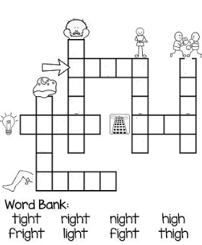

Q.6. Use these words to fill in the spaces.
flight - might – sight – night - tight- light
- The stars came out at ________________.
- When we got on the top of the mountain a wonderful ________met our eyes.
- Will you switch on the ____________ please?
- My shoes are hurting me, they are too _________.
- I ___________ be able to come over to your house this afternoon.
- The Emirates ___________ to Dubai was late this morning.

Q.7. Circle the correct option.
a. ‘I am bright, funny and red,’ _________ the red fish. (sad/said)
b. Three funny fish _________ swimming in the sea. (were/where)
c. The brown fish _________ shy. (was /were)
d. _________ a big fish came and …yum, yum, yum! (Ten/Then)
e. He _______ to my home yesterday. (come /came)

Q.8. Write the missing rhyming words in the following.
A fine feathered fish
With five furry fins
Falls onto a _______
Next to four fishy ________.
Q.9. Draw a flower, color and write two sentences to describe it.

