دولة الامارات العربية المتحدة
مدرسة الوردية الخاصة / حلوان
المرخصة من وزارة التربية والتعليم
تحت رقم ( 50 )

UNITED ARAB EMIRATES
ROSARY SCHOOL / HALWAN
Licensed from the Ministry of Education
Under No. ( 50 )

Our Vision: Innovative education for a knowledge, pioneering, and global society.
Department of English 2018-2019
Worksheet -Unit 6 Staying safe
Name:……………………… Grade2 Sec:…………. Date:…./1/2019
Q1.Mark the syllables and write the number of syllables in the brackets.
- animal ( ) 2. spider ( )
- April ( ) 4. cobra ( )
5. frog ( )
Q2. Circle the adjectives:-
- The box jellyfish has eight long tentacles.
- Blue ringed octopus has a venomous beak.
- A funnel web spider can bite through soft shoes.
Q3 - Write the rhyming words with:-
- bread - ______________ ____________
- pear - ______________ ____________
- peach -_______________ _______________
Q4. Fill in the missing letters:
- Ap__ __ l 2. J __ __ u a __ __ 3. N __ __ e __ __ __ r
- J __ __ y 5. Au __ __ __t 6. Sep __ __ __b __ __

Q5. Write one word meaning:-
- An animal , especially a non-human _____________________
- A big group of insects _____________________
- Sharp teeth which inject poison _____________________
- Harmful chemical injected when an animal
bites you. ____________________

- Long ,dangly body parts used for feeding or
Moving about _____________________

Q6. Join a word to ‘fish’ to make new compound words:-
- ______________ fish
- ______________ fish
Q7. Write the two words from the compound words given below:-
- swordfish __________________ _____________________
- seahorse __________________ _____________________
- polarbear __________________ _____________________
- underground __________________ _____________________

Q8. Draw lines to build the word. The first one has been done for you:-
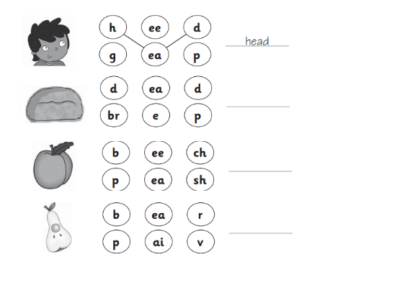

Q9. Fill in the blanks :-
- The first month of the year is ______________ .
- ____________ comes after April.
- The last month of the year is ____________________.
- ________________ comes before July.

