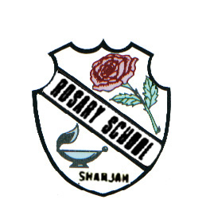
دولة الامارات العربية المتحدة
مدرسة الوردية الخاصة / حلوان
المرخصة من وزارة التربية والتعليم
تحت رقم ( 50 )

UNITED ARAB EMIRATES
ROSARY SCHOOL / HALWAN
Licensed from the Ministry of Education
Under No. ( 50 )

Our Vision: Innovative education for a knowledge, pioneering, and global society.
Department of English 2018-2019
Vocabulary Words List-3
Name ……………………………………… Grade: 3 Sec:……...... Date:…/…/….
equator (noun) an imaginary line around the middle of the earth at an equal distance from the North Pole and the South Pole
survival (noun) continuing to live
lifetime (noun) duration of life
journey (noun) an act of travelling from one place to another
blubber(noun) the layer of fat under the skin of sea mammal
amazing(adjective) wonderful
familiar(adjective) known
mammals (noun)animals ,give birth to babies rather than laying eggs and feed their young with milk
published(verb) prepare and issue (a book, magazine or paper)for public sale

