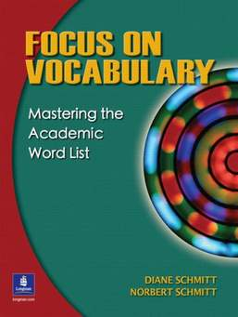
دولة الامارات العربية المتحدة
مدرسة الوردية الخاصة / حلوان
المرخصة من وزارة التربية والتعليم
تحت رقم ( 50 )

UNITED ARAB EMIRATES
ROSARY SCHOOL / HALWAN
Licensed from the Ministry of Education
Under No. ( 50 )

Department of English 2018-2019
Vocabulary Unit 5 -List 2
Name:……………………………… Grade: 4 Sec:…….. Date:……../1/2019
1-expressive: (adj) Eg: I can’t forget her face. It was so expressive of happiness.
2-descriptive : (adj) having words or adjectives to describe something.
Eg: This passage is descriptive because it describes the sea animals.
3-suggestions: (n) ideas that you can use to do something.
Eg: Do you have any suggestions about the party?
4-puff (ed): (v) to blow/ breathe in and out.
Eg: My uncle always puffs when he is angry. I hate that.
5- narrator: (n) the person who tells the story.
Eg: The narrator told the story in a very wonderful way.
6-silvery: (adj) like silver.
Eg: My grandma’s hair is silvery.
7-toddler: (n) a young child who is still learning to walk.
Eg: My uncle’s toddler is very naughty and noisy.
8- clutch(ing): (v) to hold something tightly.
Eg: He stood clutching a microphone.
9-pretend (ed): (v) to act something as if it is true while it is not true.
Eg: Mum shouted at me and my sister, but we kept playing with the small toys and pretended like nothing happened.
10- infinitesimal: (adj) very small/ tiny.
Eg: My brother spends most of his time playing with his infinitesimal cars.

11- admiringly: (adv) respectfully / with admiration
Eg: My dad looked at me admiringly while drawing the picture. He liked the drawing so much.
12- shamelessly: (adv) without shame.
Eg: It’s a shame to shout at elders or even argue with them.
13-lavishly: ( adv) richly / extravagantly
Eg: The flowers were displayed lavishly.
14: slightest: (adj) smallest
Eg: If you have even the slightest doubt, then don’t do it.
13-embarrassed: (adj) ashamed
Eg: I felt embarrassed yesterday when the teacher asked me to introduce myself in front of the class.
14-discomfit: (v): to make somebody upset.
Eg: “Don’t discomfit me by behaving badly with your classmates, my child,” said the father.
14-enraptured: (adj): happy
Eg: We are so enraptured by the possibility of going on a school trip next week.

