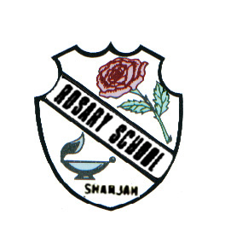
UNITED ARAB EMIRATES
ROSARY SCHOOL / HALWAN
Licensed from the Ministry of Education
Under No. ( 50 )

دولة الامارات العربية المتحدة
مدرسة الوردية الخاصة / حلوان
المرخصة من وزارة التربية والتعليم
تحت رقم ( 50 )

Our Vision: Innovative education for a knowledge, pioneering, and global society.
Department of English 2018-2019
Grade5 -Vocabulary List 3

Name ……………………………………… Grade: ……… Sec: ……...... Date: …/…/….

1. eerie : (adj.) strange in a frightening and mysterious way.

2. enterprising: (adj.) good at thinking of and doing new and difficult things, especially things that will make money.

3.determination: (n.) the ability to continue trying to do something, although it is very difficult.

4. phenomenon: (n.) something unusual or interesting that exists and can be seen, felt or tasted.

- 5.indelibly: (adv.) in a way that cannot be removed or forgotten.

6. communicated: (v.) to share information with others by speaking, writing, moving your body, or using other signals.

7. triumphant: (adj.) having achieved a great victory (winning a war or competition) or success, or feeling very happy and proud because of such an achievement.

8. syllables: (n.) a single unit of speech, either a whole word or one of the parts into which a word can be separated, usually containing a vowel.

9. horizon: (n.)
* the place in the distance where the earth and sky seem to meet.
* A person’s horizons are the limit of that person’s ideas, knowledge, and experience.

10. opposition: (n.) strong disagreement.

11. press: (v.) to push something firmly, often without causing it to move permanently further away from you.
press: (n.) * newspapers and magazines, and those parts of television and radio that broadcast news, or reporters and photographers who work for them.

12. proposition: (n.) an offer or suggestion, usually in business.

13. debate:
(n.) * serious discussion of a subject in which many people take part.
(v.) * to try to make a decision about something.

14. concise: (adj.) short and clear, expressing what needs to be said without unnecessary words.

15. address:
(n.) * the number of the house, name of the road, and name of the town where a person lives or works, and where letters can be sent.
(v.) * to speak or write to someone.

16. plankton: (n.) very small plants and animals that float on the surface of the sea and on which other sea animals feed.

