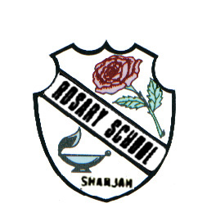
دولة الامارات العربية المتحدة
مدرسة الوردية الخاصة / حلوان
المرخصة من وزارة التربية والتعليم
تحت رقم ( 50 )

UNITED ARAB EMIRATES
ROSARY SCHOOL / HALWAN
Licensed from the Ministry of Education
Under No. ( 50 )

Our Vision: Innovative education for a knowledge, pioneering, and global society.
Department of English 2018-2019
Grade2- Worksheet – 1(Unit-6)
Name:_____________________ Sec:____________ Date:____/1/2019

Q1 - Identify and match the name to its creature.
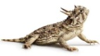
1- hellbender
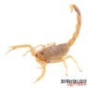
2. horned lizard
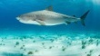
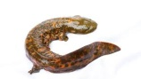
3. tiger shark

4. scorpion

Q2- Write the word that has similar meaning.

(swarm - fangs - creature - unsafe – poisonous)

1 - Sharp teeth which inject poison. ___________________

2 - A big group of insects. ___________________

3- An animal, especially a non human. ___________________

4 - Dangerous to eat or touch. ___________________

5 - Dangerous ___________________

Q3 - Guess the animal and write its name.

1 - It aims venom at eyes, which can cause blindness. ________________

2 - It can even bite through soft shoes. ________________

3 - They sting with their tails. ________________

4 - It’s deadly to eat, or even to touch. ________________

5 - It has long venomous tentacles. ________________

