دولة الامارات العربية المتحدة
مدرسة الوردية الخاصة / حلوان
المرخصة من وزارة التربية والتعليم
تحت رقم ( 50 )

UNITED ARAB EMIRATES
ROSARY SCHOOL / HALWAN
Licensed from the Ministry of Education
Under No. ( 50 )

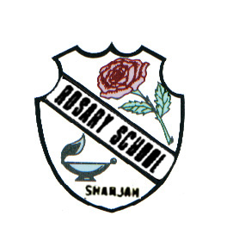

Our Vision: Innovative education for a knowledge, pioneering, and global society.
Department of English 2018-2019
Vocabulary List- Grade 3(Unit-4)
Name ……………………………………… Grade:……… Sec:……...... Date:…/1/2019

medicine(noun) -treatment for illness

everywhere(adverb)-in all places
dangerous(adjective)-unsafe
innocent(adjective)-without fault
wonderful(adjective)-great, excellent
fascinating(adjective)-extremely interesting
addicted(adjective)-the habit of using something
retold(verb)-retell
famous(adjective)-well known
bookworms(noun)-a person who enjoys reading
author(noun)-writer
references(noun)-the action of mentioning
vegetarian(noun)-a person who doesn’t eat meat or fish
information(noun)-details

