دولة الامارات العربية المتحدة
مدرسة الوردية الخاصة / حلوان
المرخصة من وزارة التربية والتعليم
تحت رقم ( 50 )

UNITED ARAB EMIRATES
ROSARY SCHOOL / HALWAN
Licensed from the Ministry of Education
Under No. ( 50 )

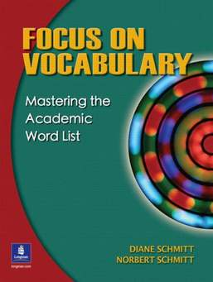
English Department 2018-2019
Vocabulary List Unit 4 –(Grade4)

1-setting: (n) the time and place in which the action of a book, movie, etc., takes place
2-characters : (n) the people who act in a film or a play.
3-cunning: (adj) getting what is wanted in a clever way.
4-greedy: (adj) having a selfish desire to have more of something.
5- conflict: (n) a disagreement or argument.
6-satisfy: (v) to cause someone to be happy or pleased.
7-knack: (n) a natural skill at doing something / a talent
8- conclusion: (n) the end of a process or text.
9- brave (adj) ready to face danger or pain with courage.
10- courageous (adj) very brave .
11- fierce: (adj) very violent / wild
12- chief: ( n ) the person who is the leader of a group of people ,of an organization ,etc.
13-completely: ( adv) totally.
Example: The houses were completely damaged after the earthquake.

14- possession: (n) something that is owned by someone.
Ex: The family lost all of its possessions in the fire.
15-resolution: (n) The act of finding an answer or solution to a conflict or a problem.
16-merchant: (n) someone who buys and sells goods especially in large amounts.
17-conflict: (n) strong disagreement between people.
18-conversation: (n) an informal talk involving two people or a small group of people.
19-hurriedly : ( adv) quickly.
20-witnesses: (Pl.n) the people who see something like a crime or present at an event and can say what happened.

