UNITED ARAB EMIRATES
دولة الامارات العربية المتحدة
مدرسة الوردية الخاصة / حلوان
المرخصة من وزارة التربية والتعليم
تحت رقم ( 50 )

ROSARY SCHOOL / HALWAN
Licensed from the Ministry of Education
Under No. ( 50 )
Our Vision: Innovative education for a knowledge, pioneering, and global society.

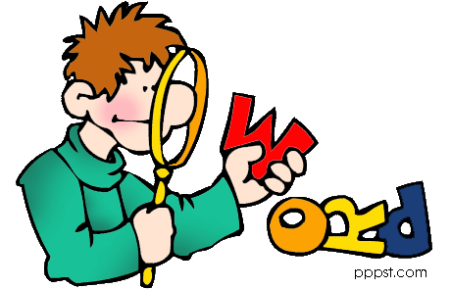
Department of English – 2018-2019
Grade6-Vocabulary List (Unit-4)

 | Word | meaning | Example
1 | criteria - (n) plural of criterion | a standard by which you judge, decide about, or deal with something | The Health Service should not be judged by financial criteria alone.
2 | appreciate (v) | to recognize or understand that something is valuable | I don’t think you appreciate how much time I spent preparing this meal.
3 | futuristic (adj.) | strange and very modern | Her latest novel is a futuristic thriller, set some time in the late twenty-first century.
4 | concept (n) | a principle or idea | It is very difficult to define the concept of beauty.
5 | release (v) | to give freedom or free movement to someone or something | He was released from prison after serving two years of a five-year sentence.
6 | euphemism  (n) | a word or phrase used to avoid saying an unpleasant word. | 'Senior citizen' is a euphemism for 'old person'.
7 | irritation (n) | Make angry | Traffic noise is just one of several minor irritations.
8 | exasperated (adj.) | annoyed | He’s becoming increasingly exasperated with the situation.
9 | advantages (n) | a condition giving a greater chance of success. | The advantage of booking tickets in advance is that you get better seats.
10 | maturity (n) | the state of being completely grown physically. | How long does it take for the chicks to grow to maturity?
11 | universe (n) | everything that exists, especially all physical matter, including all the stars, planets, galaxies, etc | Is there intelligent life elsewhere in the universe?
12 | dimension (n) | a measurement of something in a particular direction, especially its height, length or width. | Please specify the dimensions (= the height, length and width) of the room.
13 | duplication (n) | a copy of something. | I have made duplications of all important documents.
14 | tattletale (n) | a child, who secretly tells someone in authority, that someone else has done something bad, often in order to cause trouble. | She loves to poke her nose into everyone's business. She also likes to be a tattletale, and Albert listens to most of what she says.
15 | solemnly (adv.) | seriously and without any humour | I solemnly promise to tell the truth.
16 | initial (adj.) | beginning | My initial surprise was soon replaced by delight.
17 | standardize (v) | to make things of the same type all have the same basic features. | Math is an academic art that we had to standardize so it would make sense to everyone.
18 | behaviour (n) | the way in which one acts or conducts oneself, especially towards others. | I'm surprised by her bad behavior toward her friends.
19 | variety (n) | a different type of something: | Our supermarket stocks apples in several different varieties.
20 | personality (n) | the type of person you are, which is shown by the way you behave, feel and think: | He is well qualified for the job, but he lack personality. ( he is a boring person)

