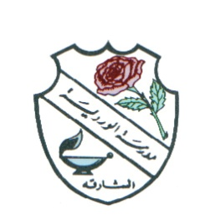
-
UNITED ARAB EMIRATES
ROSARY SCHOOL / HALWAN
Licensed from the Ministry of
Education
Under No. (50)

دولة الامارات العربية المتحدة
مدرسة الوردية الخاصة / حلوان
المرخصة من وزارة التربية والتعليم
تحت رقم (50)

Our Vision: Innovative education for a knowledge, pioneering, and global society.

Department Of Mathematics 2018-2019
Multiplication Table Practice Schedule –Second Term
DATE | Grade 2 | Grade 3 | Grade 4 | Grade 5 | Grade 6
Jan 20th-24th | Table 2 | Tables  2,5 and 8 | Tables  5,6 and 12 | Tables  2 to 7 &13 | Tables  2 to 7 &13
Jan 27th –Jan 31st | Table 3 | Tables  3,4 and 6 | Tables  2, 3,4 and 8 | Tables  6 to 10 | Tables  6 to 10& 14
Feb 3rd – 7th | Table 5 | Tables  7 & 9 | Tables  7 & 9 | Tables  8 to 13 | Tables  8 to 13& 15
Feb 10^{th-} 14th | Table 10 & Tables 2,3,5,&10 | Tables 2-11 | Tables 10 , 11 , 12 & 2-12 | Tables 2 to 13 | Tables 2 to 15
Multiplication Table Test-II  (Feb 17the -21th ) | Multiplication Table Test

