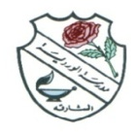
ROSARY SCHOOL, HALWAN
WEEKLY REVIEW
GRADE- 6
Jan 27, 2019 – Jan 31, 2019

ASSESSMENT | SUNDAY | MONDAY | TUESDAY | WED | THURS
 |  | English Class Assessment -1 |  |  | Math Quiz:  Unit 3: Lesson 1,3 and 4  WB pages 26,27,30-33
ENGLISH | Unit 4 “Facts, foibles and fables”  Reading and Speaking: Read information and have a group discussion about different types of Phobias.. Student’s Book pages 55–56  Read information about the origin of the word “phobia” and the most common phobias in the world.  Reading: Student’s Book: page 57,58 and Comprehension Copybook  Answer comprehension questions about different creatures.  Grammar: Complex sentences - Student’s Book pages 59,60 and Workbook pages 29,30  Explain the components of a complex sentence.  Note:  Class Assessment 1 will be on 28th January 2019  Study the following topics in Unit 4:  - Vocabulary list 1 (Words and meanings)  - Subject and predication  - Punctuation usage  - Figurative language
MATHS | Unit 9:  - Subtracting near multiples  - Written subtraction of decimals  - Positive and negative numbers  Homework:  WB pages 92 & 93 Challenge 2 Q 1, Q2 (c, d ,e)  WB page 94 Challenge 2 Q 1(a-f)  IMPORTANT: Please note that the above mentioned exercise for homework to be attempted by the students only after the completion of relative topics in the class, which will be informed by the teachers through the class diary.
SCIENCE | 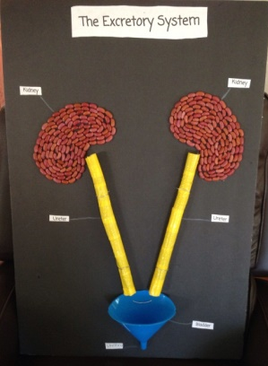  Topic 1 Humans and animals 1.9 The excretory system and the kidneys SB pgs. 18-19, WB pgs. 16-17 1.10 Essential functions of major organs WB pgs.20-21, WB pg.18  *Use scientific names for some major organs of the excretory system.  *Describe the main functions of the major organs of the systems.  Watch these links over a period of 1 week: Revise one system per day.  https://www.youtube.com/watch?v=dZREDWD_5bA  https://www.youtube.com/watch?v=TZMJeZL-BVg  https://www.youtube.com/watch?v=rT_vjf5fMw4 (urinary system)  Group Project Bring kidney beans, straws, modelling clay, funnel or upper half of plastic bottle (cut off at home), red sponge or foam, marker, glue and duct tape. [10M]
ARABIC | - درس المسجد النبوي .  - تركيب العطف .
RELIGION | - سورة السجدة  - الصبر واليقين من كتاب الجزء الثاني .
SOCIAL STUDIES | - درس : جمهورية الهند .
COMPUTER | Chapter -3 Multimedia: 3.5 Creating your visuals
FRENCH | Unité 6: Le jour du marché [Livre pages 36-37]
MORAL EDUCATION | Unit 3- Lesson 2 Cultural change. HW : Stick pictures of any 5 museums in the UAE and label it correctly.

