دولة الامارات العربية المتحدة
مدرسة الوردية الخاصة / حلوان
المرخصة من وزارة التربية والتعليم
تحت رقم ( 50 )

UNITED ARAB EMIRATES
ROSARY SCHOOL / HALWAN
Licensed from the Ministry of Education
Under No. ( 50 )

Our Vision: Innovative education for a knowledge, pioneering, and global society.

SUB: MATHEMATICS 2018 - 2019
TERM - 2
WORKSHEET -1 GRADE 4 …….
Name : …………………...…..… Roll no. : ……….Date : ………………..
- Find the exact answer: 110 +70
- 18 B) 81 C)180 D)810
- Estimate 123 + 685. The sum is between which numbers?
A) 400 and 600 B) 700 and 900
C) 1,000 and 1,200 D) 1,300 and 1,500
- Find the exact answer: 365 - 56
- 300 B)309 C)311 D)421
- Estimate 999 - 103. The difference is in between which numbers?
A) 1,300 and 1,500 B) 1,000 and 1,200
C) 800 and 1000 D) 400 and 600
- Find the exact answer: 145 + 281 + 62
- 426 B)488 C)946 D)1,046
- Which of these letters has a line of symmetry?
- P B)T C)F

7) What was the temperature at 9:00 A.M. in Springfield on Day 3?
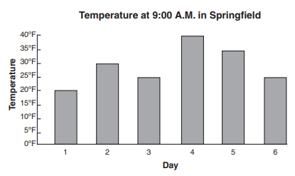
A) 20°F B) 25°F C)30°F D)35°F
8) Compare the shaded regions. Which symbol belongs in the square?
A) < B)> C) = D)None of them.
9) Look at the pattern below.
If the pattern continues, how many dots will be in the next triangle?
A) 5 B) 10 C) 15 D) 20
10) What does the p equal in 3 + p = 15?
A) 3 B) 5 C) 12 D) 18
11) Sue is having some friends over for pizza. She surveyed what toppings they would like on their pizza.
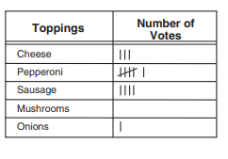
What can Sue most likely conclude from her survey?
- More of Sue’s friends like cheese than pepperoni pizza
- Sausage is the group’s second-favorite type of pizza
- A pizza with both pepperoni and mushrooms should be ordered
- Sue needs to order only one onion pizza.
12) The table shows the average (mean) temperature for several years in Thomas’ hometown.
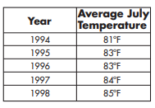
By how much did the average (mean) temperature increase from 1995 to 1998?
- 2°F B) 3°F C) 4°F D) 5°F
13) Mrs. Barber’s class kept track of how many pages they read during the school year. Each star on the pictograph stands for 50 pages.
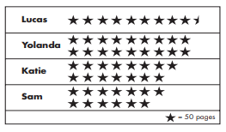
How many pages did Lucas read?
A) 425 B) 450 C) 475 D) 500
14) This graph shows the number of each kind of item Marcia recycled last week.
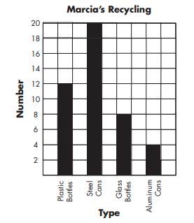
How many more plastic bottles than glass bottles did Marcia recycle?
A) 2 B)4 C)8 D)12
15) When 10 is dropped into this machine, it comes out as 5.
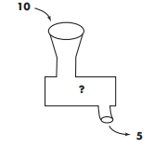
When 16 is dropped in, it comes out as 8. When 4 is dropped in, it comes out as 2. If 8 is dropped into the machine, what number will it come out as?
A)3 B)4 C)5 D) 6

