دولة الامارات العربية المتحدة
مدرسة الوردية الخاصة / حلوان
المرخصة من وزارة التربية والتعليم
تحت رقم ( 50 )

UNITED ARAB EMIRATES
ROSARY SCHOOL / HALWAN
Licensed from the Ministry of Education
Under No. ( 50 )

Our Vision: Innovative education for a knowledge, pioneering, and global society.
English Worksheet-1 (Grade 2)
Unit-7 When Arthur Wouldn’t Sleep
Name:_____________________ Sec:________ Date:___/2/2019
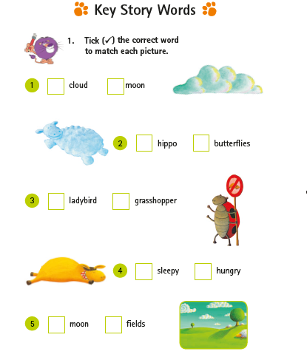

Q1.Circle ﬁve words in the word box that describe dancing in the story.

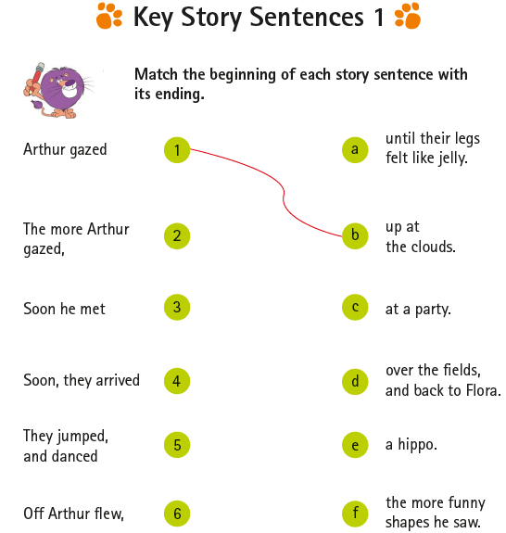Q2. Match the beginning of each story sentence with its ending.

Q3. Fill in the blanks with words from the box.
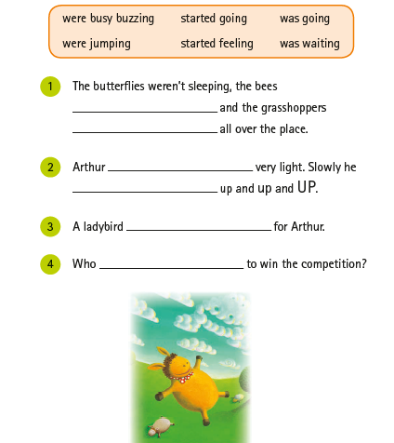

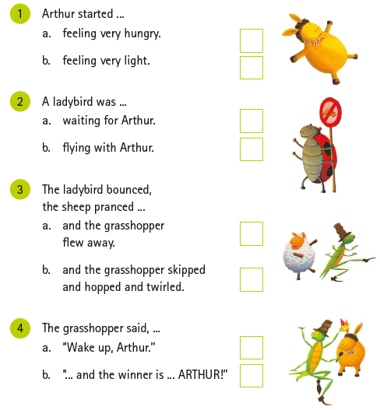Q4. Tick () the correct ending to each story sentence. Look at the pictures for clues.

