FIRST TERM WORSHEET [2018 – 2019]
Unit 4 – Lessons 1 & 6 (Oral Exam – 10th Feb to 14th Feb)
Subject: Computer / Grade: 2____
Name : ___________________________________ Roll no. : ________ Date : 03/02/2019

- Label the screen:
This is MS Excel screen.
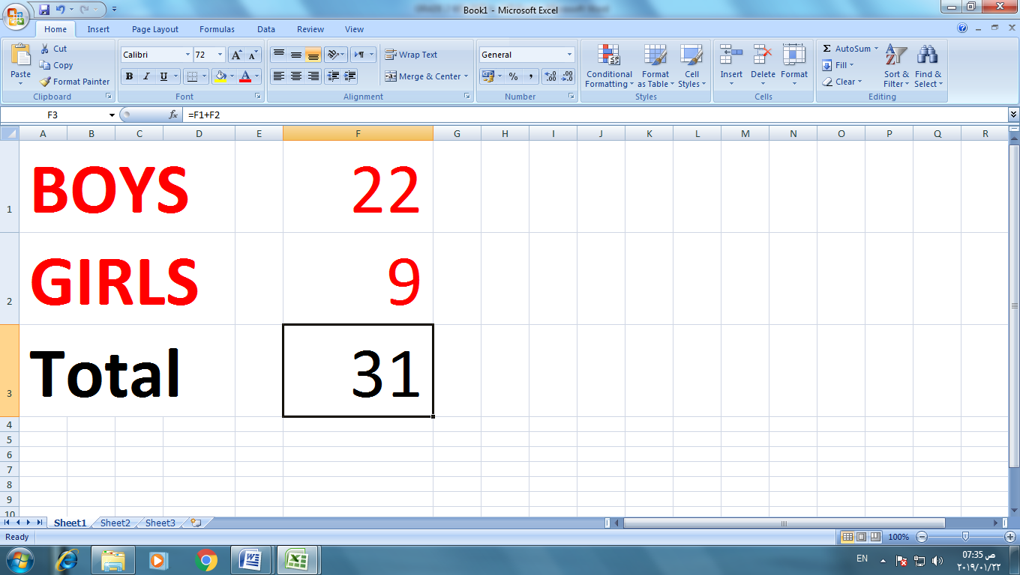
Formula
Label

Value
Cell

Cell
Reference
Answer

- Fill in the blanks:

{ cell reference, letter, number, cell, column, row, spreadsheet, name }

- The spreadsheet is made of columns and rows.

- Each column has a letter. Each row has a number, where a column crosses a row this makes a cell.

- Every cell in a worksheet has a name. The name made of the column letter and the row number. This name is called the cell reference.

- Label the icons:
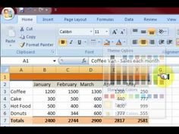
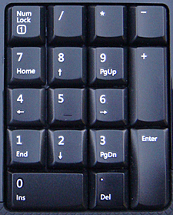
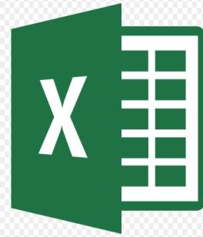
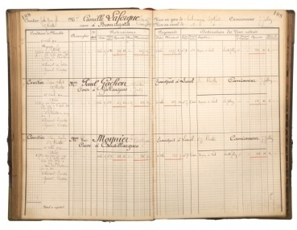

MS Excel Numeric Keypad Ledger book Spreadsheet

IV. Label the keyboard:
Multiply (*)
Num Lock
Equals (=)
Letter
Number
Minus (-)
Plus (+)

Enter key
Space Bar key
Shift key

