FIRST TERM WORSHEET [2018 – 2019]
Unit 4 – Lessons 1 & 6 (Oral Exam – 10th Feb to 14th Feb)
Subject: Computer / Grade: 2____
Name : ___________________________________ Roll no. : ________ Date : 03/02/2019

- Label the screen:
This is ________________________ screen.
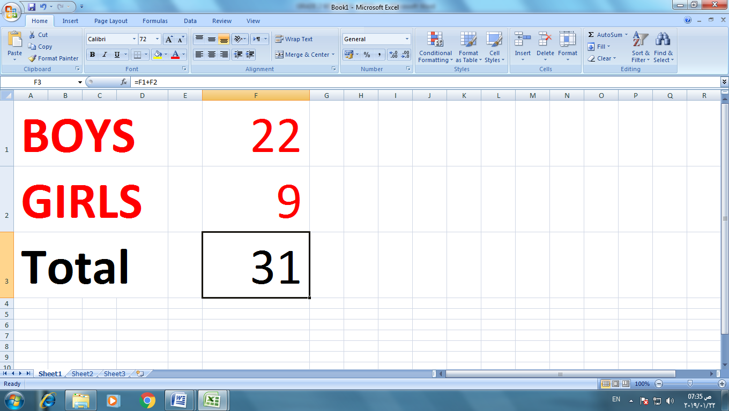

- Fill in the blanks:

{ cell reference, letter, number, cell, column, row, spreadsheet, name }

- ______________ is made of columns and rows.

- Each column has a ______________. Each row has a ______________, where a

column crosses a row this makes a ______________.

- Every cell in a worksheet has a ______________. The name made of the

______________ letter and the ______________ number. This name is called

the ______________.

- Label the icons:
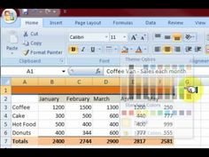
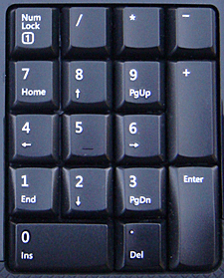
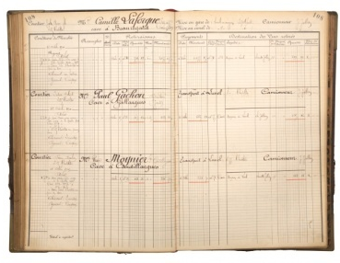

IV. Label the keyboard:

