UNITED ARAB EMIRATES
دولة الامارات العربية المتحدة
مدرسة الوردية الخاصة / حلوان
المرخصة من وزارة التربية والتعليم
تحت رقم ( 50 )

ROSARY SCHOOL / HALWAN
Licensed from the Ministry of Education
Under No. ( 50 )
Our Vision: Innovative education for a knowledge, pioneering, and global society.

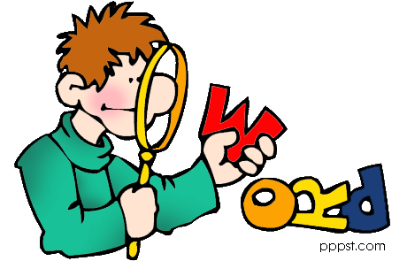
Department of English – 2018-2019
Grade6- Vocabulary List 4

Name:______________________ Sec:_________ Date:____/2/2019

 | Word | meaning | Example
1 | vibration (n) | to shake slightly and quickly | Vibrations were felt hundreds of miles from the center of the earthquake.
2 | injecting (v) | to use a needle to put a liquid such as a drug into a person's body | Phil is a diabetic and has to inject himself with insulin every day.
3 | scorpion (n) | a small insect which lives in hot dry areas and has a long body and a curved tail with a poisonous sting. | I would scream very loudly if I saw a scorpion in my room.
4 | co-ordinate (v) | to make various things work effectively as a whole. | We try to coordinate our activities with those of other groups.
5 | subordinate (n) | having a lower or less important position. | He was always friendly to his subordinate officers.
6 | venomous  (adj.) | poisonous | The cobra sank its venomous fangs into his hand.
7 | gracious (adj.) | behaving in a pleasant, polite, calm way. | He was gracious enough to thank me.
8 | delighted (adj.) | to give someone great pleasure or satisfaction. | Peter's success at college delighted his family.
9 | compliments (n) | an expression of your appreciation or respect. | That was an excellent presentation! My compliments.
10 | flatterers (n) | someone who praises people without being sincere. | You can’t believe a word Tony says, he’s real flatterer.
11 | dependable (adj.) | If someone or something is dependable, you can trust them or have confidence in them. | I need someone dependable to look after the children while I'm at work.
12 | influence (n) | the power to have an effect on people or things. | Tom hoped to exert his influence to make them change their minds.
13 | mosquitoes (n) | a small flying insect that bites people and animals and sucks their blood. | Some types of the anopheles mosquitoes transmit malaria to humans.
14 | personification  (n) | the attribution of a personal nature or human characteristics to something non-human. | She played a character who was the personification of evil.
15 | weight (n) | the amount that something or someone. | There was a slight decrease in his weight after a week of dieting.
16 | scarlet (adj.) | bright red. | He went scarlet with shame and embarrassment.
17 | forbidden (v) | not permitted, especially by law. | Smoking is forbidden in the cinema.
18 | rattlesnakes (n) | poisonous snakes. | When rattlesnake is annoyed, it produces a loud nose by shaking its tail.
19 | hammock (n) | A type of bed used outside which ties between two trees or poles so that it swings. | The old man is sleeping in a hammock hanging between two trees.
20 | technique (n) | a way of doing an activity which needs skills. | She's a wonderfully creative dancer but she doesn't have the technique of a truly great performer.

Paragraph {Student’s Book page 68}
When telescopes were invented in 1609, scientists pointed them at the sky began to find out much more about space. Italian scientist, Galileo used an early telescope to see Saturn’s rings and Jupiter’s moons, and he discovered that the Milky Way was made of billions of stars.

